1. Given the provided data, what are **three conclusions** we can draw about Kickstarter campaigns?

From the information extracted from the data we have made the following conclusions:

1. Kickstarter investment in ‘Theater’, ‘Film & Video’ and ‘Music’ categories have yielded the best results with a minimum of 58% successful rate is all these categories.

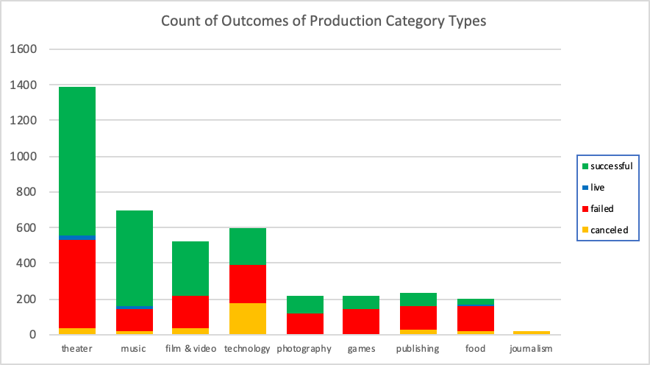

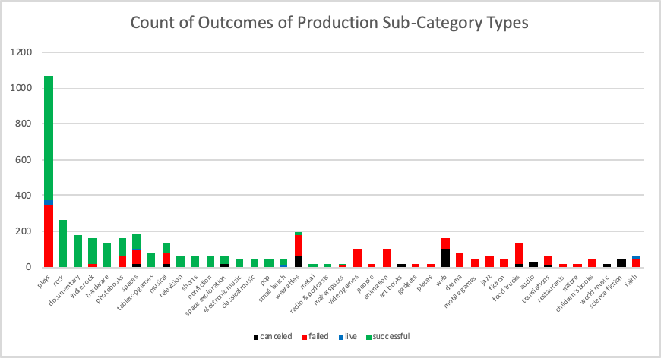‘Plays’ was the most successful sub-category under ‘Theater’. The ‘Rock’ sub-category was the best performing under ‘Music’, and ‘Documentary’ productions were the best sub-category under ‘Film & Video’, both yielding 100% success rate.

***Note: These two charts are redrawn after the results were SORTED on number of successful projects in each category and subcategory***

1. The analysis indicates that starting in year 2014 and beyond, Kickstarter took on more than 3 times production projects than they did from 2009 through 2013. The percentage of successful projects declined noticeably as illustrated below in both actual numbers and percentage of total.

1. The analysis further illustrates that the higher the goal for a production project, the chances of the project become successful fell. The information in the following two charts illustrate this conclusion.

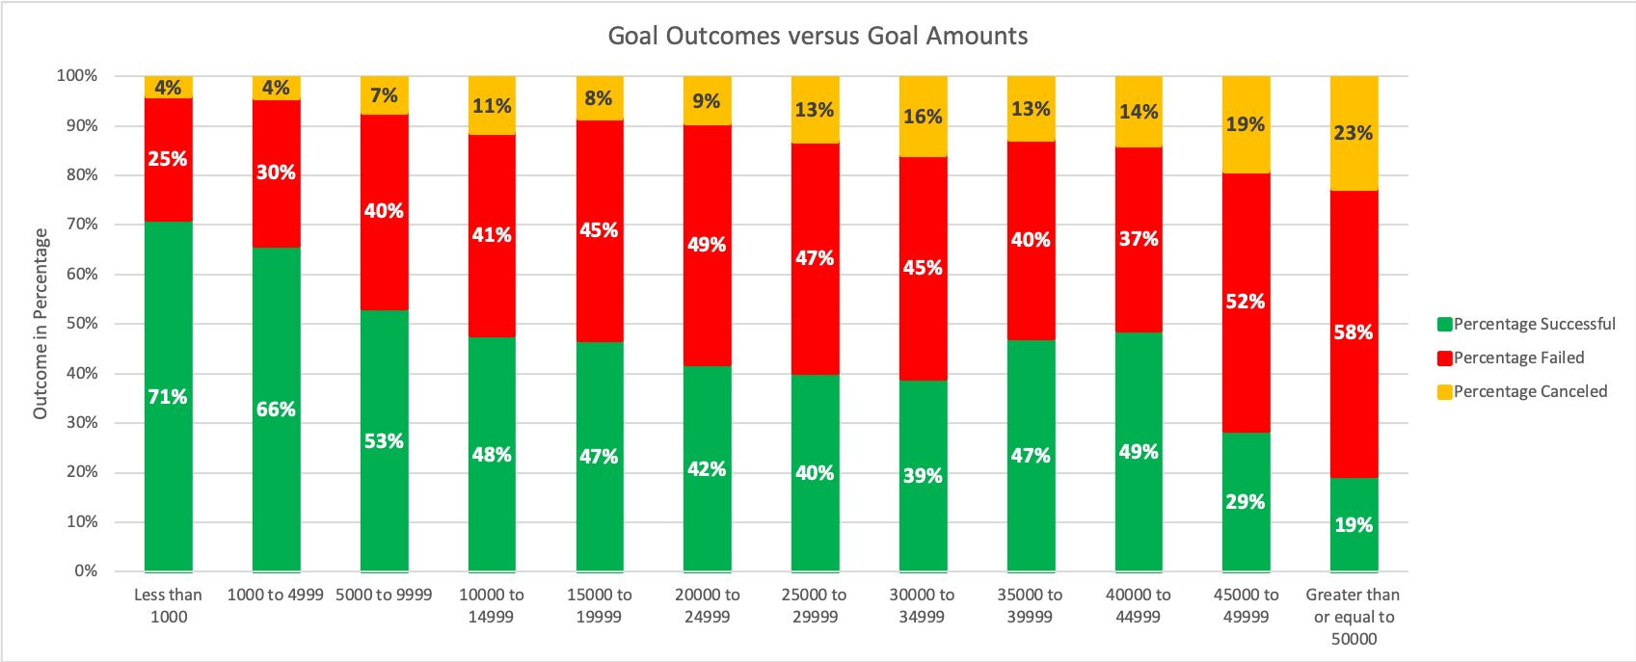

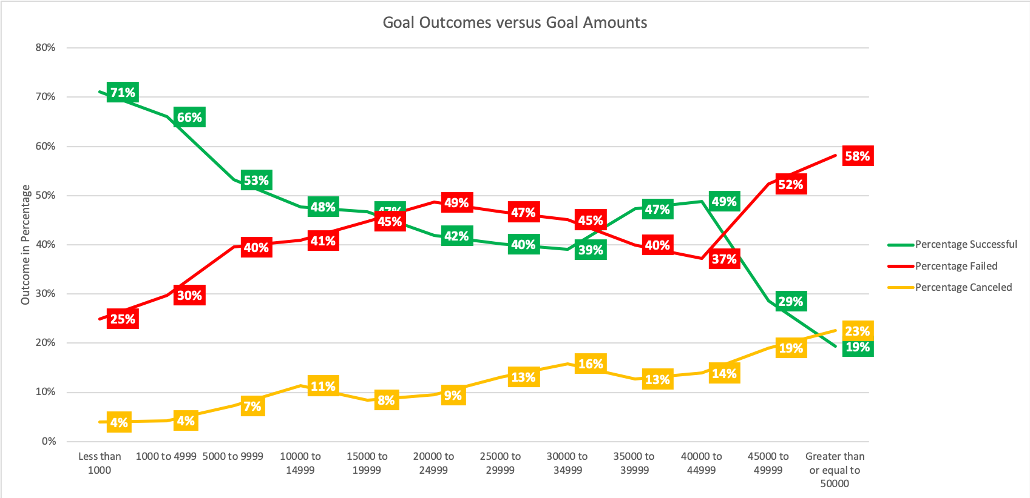

The above is consistent with conclusion II, where the information illustrated that as the number of production project investments dramatically increased in 2014, the ‘successful’ rate dropped significantly.

Based on conclusions I, II, and III, we can conclude that Kickstarter is more successful with producing fewer projects with lower project goals, and has core competencies in 3 specific areas: Theater/Play, Music/Rock, and Film & Video/Documentaries.

1. What are some limitations of this dataset?

The dataset does not provide sufficient data about the resources Kickstarter retained from 2009 through 2017. It invested in 3X more projects in 2014, but it is unclear if it had sufficient resources to support successful outcomes comparable to what they had from 2009 through 2013, when more than 60% of the projects were successful, and 30% failed. Having this data may explain why after 2014 more than 50% of the projects failed. Perhaps Kickstarter grew too fast in 2014 and was unable to obtain the necessary resources (human, capital, technology, etc.) to support the 3X growth.

For about 18 sub-categories, there were no successful projects at all, regardless of goal, or launch year. There are no data in the dataset that is uniquely different for these sub-categories without ‘successful’ status.

3. What are some other possible tables and/or graphs that we could create?

Since the data illustrates that higher the goal amount, the less projects were successful, we should look out the grouping by the 12-groups over time, especially between 2014 and 2017, to see if Kickstarter invested in more projects with higher goals from 2014 to 2017 or not.

Similarly, we should also look out the mix of category and subcategory types from 2009 through 2017, especially after 2014 to see if Kickstarter invested in categories and sub-categories that it did not do prior to 2013, or if it did, if and how the mix changed.